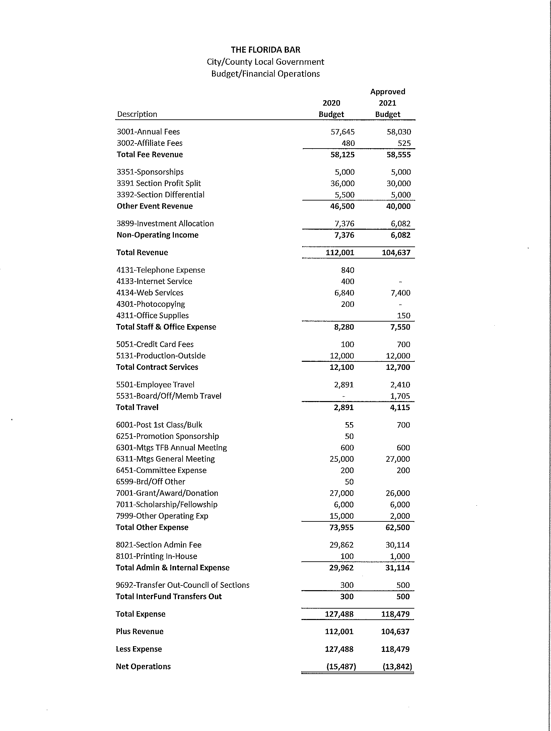

SECTION REIMBURSEMENT POLICIES:
General: All travel and office expense payments are in accordance with Standing Board Policy 5.54.
Travel expenses for other than members of Bar staff may be made if in accordance with SBP 5.54(a)-(e) which is available from Bar headquarters upon request.

